Coming Up for Families at
Christ Church Parbold in July
Sunday 5th July – 9:30am

Family Service – Theme: Living Under God’s Promises
A warm welcome for everyone to our lively and interactive Family service where we’ll also have our Youth Pop Up Band playing for us.


Saturday 11th July 12-5pm
Parbold Village Show
Come and say hello to us at our stall at this year's Parbold Village Show, which is taking place on the Alder Lane Playing Fields between 12-5pm. We’ll have craft activities, games and much more.

Sunday 12th July – 10:30am
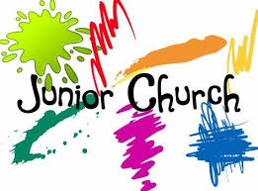
Junior Church & Weekly Children’s Resources
Junior Church meets in the Scout Hut for ages 4–13. At the back of church each week we also have:-
• Tots’ Area (0–3yrs
• Lending Library
• Resource Table with extra children’s activities.
Junior Church will be back after it’s summer break on Sunday 13th September

Sunday 12th July – 6:00pm

Soul Action Café (Youth)
Our youth group is for Year 7+ and meets in the Scout Hut. and we’re also offering Y6 children a taster session and an extended welcome to any PDA pupils who also may be interested in joining us.
Café will pause after this, resuming in September.
For more details about our services, please contact Rev Sue: susanktimmins@aol.com

