Coming Up for Families at
Christ Church Parbold in May
Sunday 3rd May – 10:30am

All Age Sunday Service
A warm welcome for everyone to our All Age Sunday service which has the theme of ‘Living Hope’ . We’ll also have our Youth Pop Up Band playing for us.


Sunday’s 3rd, 17th & 31st May – 6:00pm
Soul Action Café (Youth)
Our youth group is for Year 7+ and meets in the Scout Hut.

Sunday 10th May – 10:30am
Junior Church & Weekly Children’s Resources
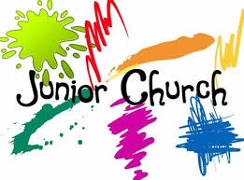
Junior Church meets in the Scout Hut for ages 4–13. At the back of church each week we also have:
• Tots’ Area (0–3yrs)
• Lending Library
• Resource Table with extra children’s activities

Sunday 17th May – 9:30am
Muddy Church at the Hut
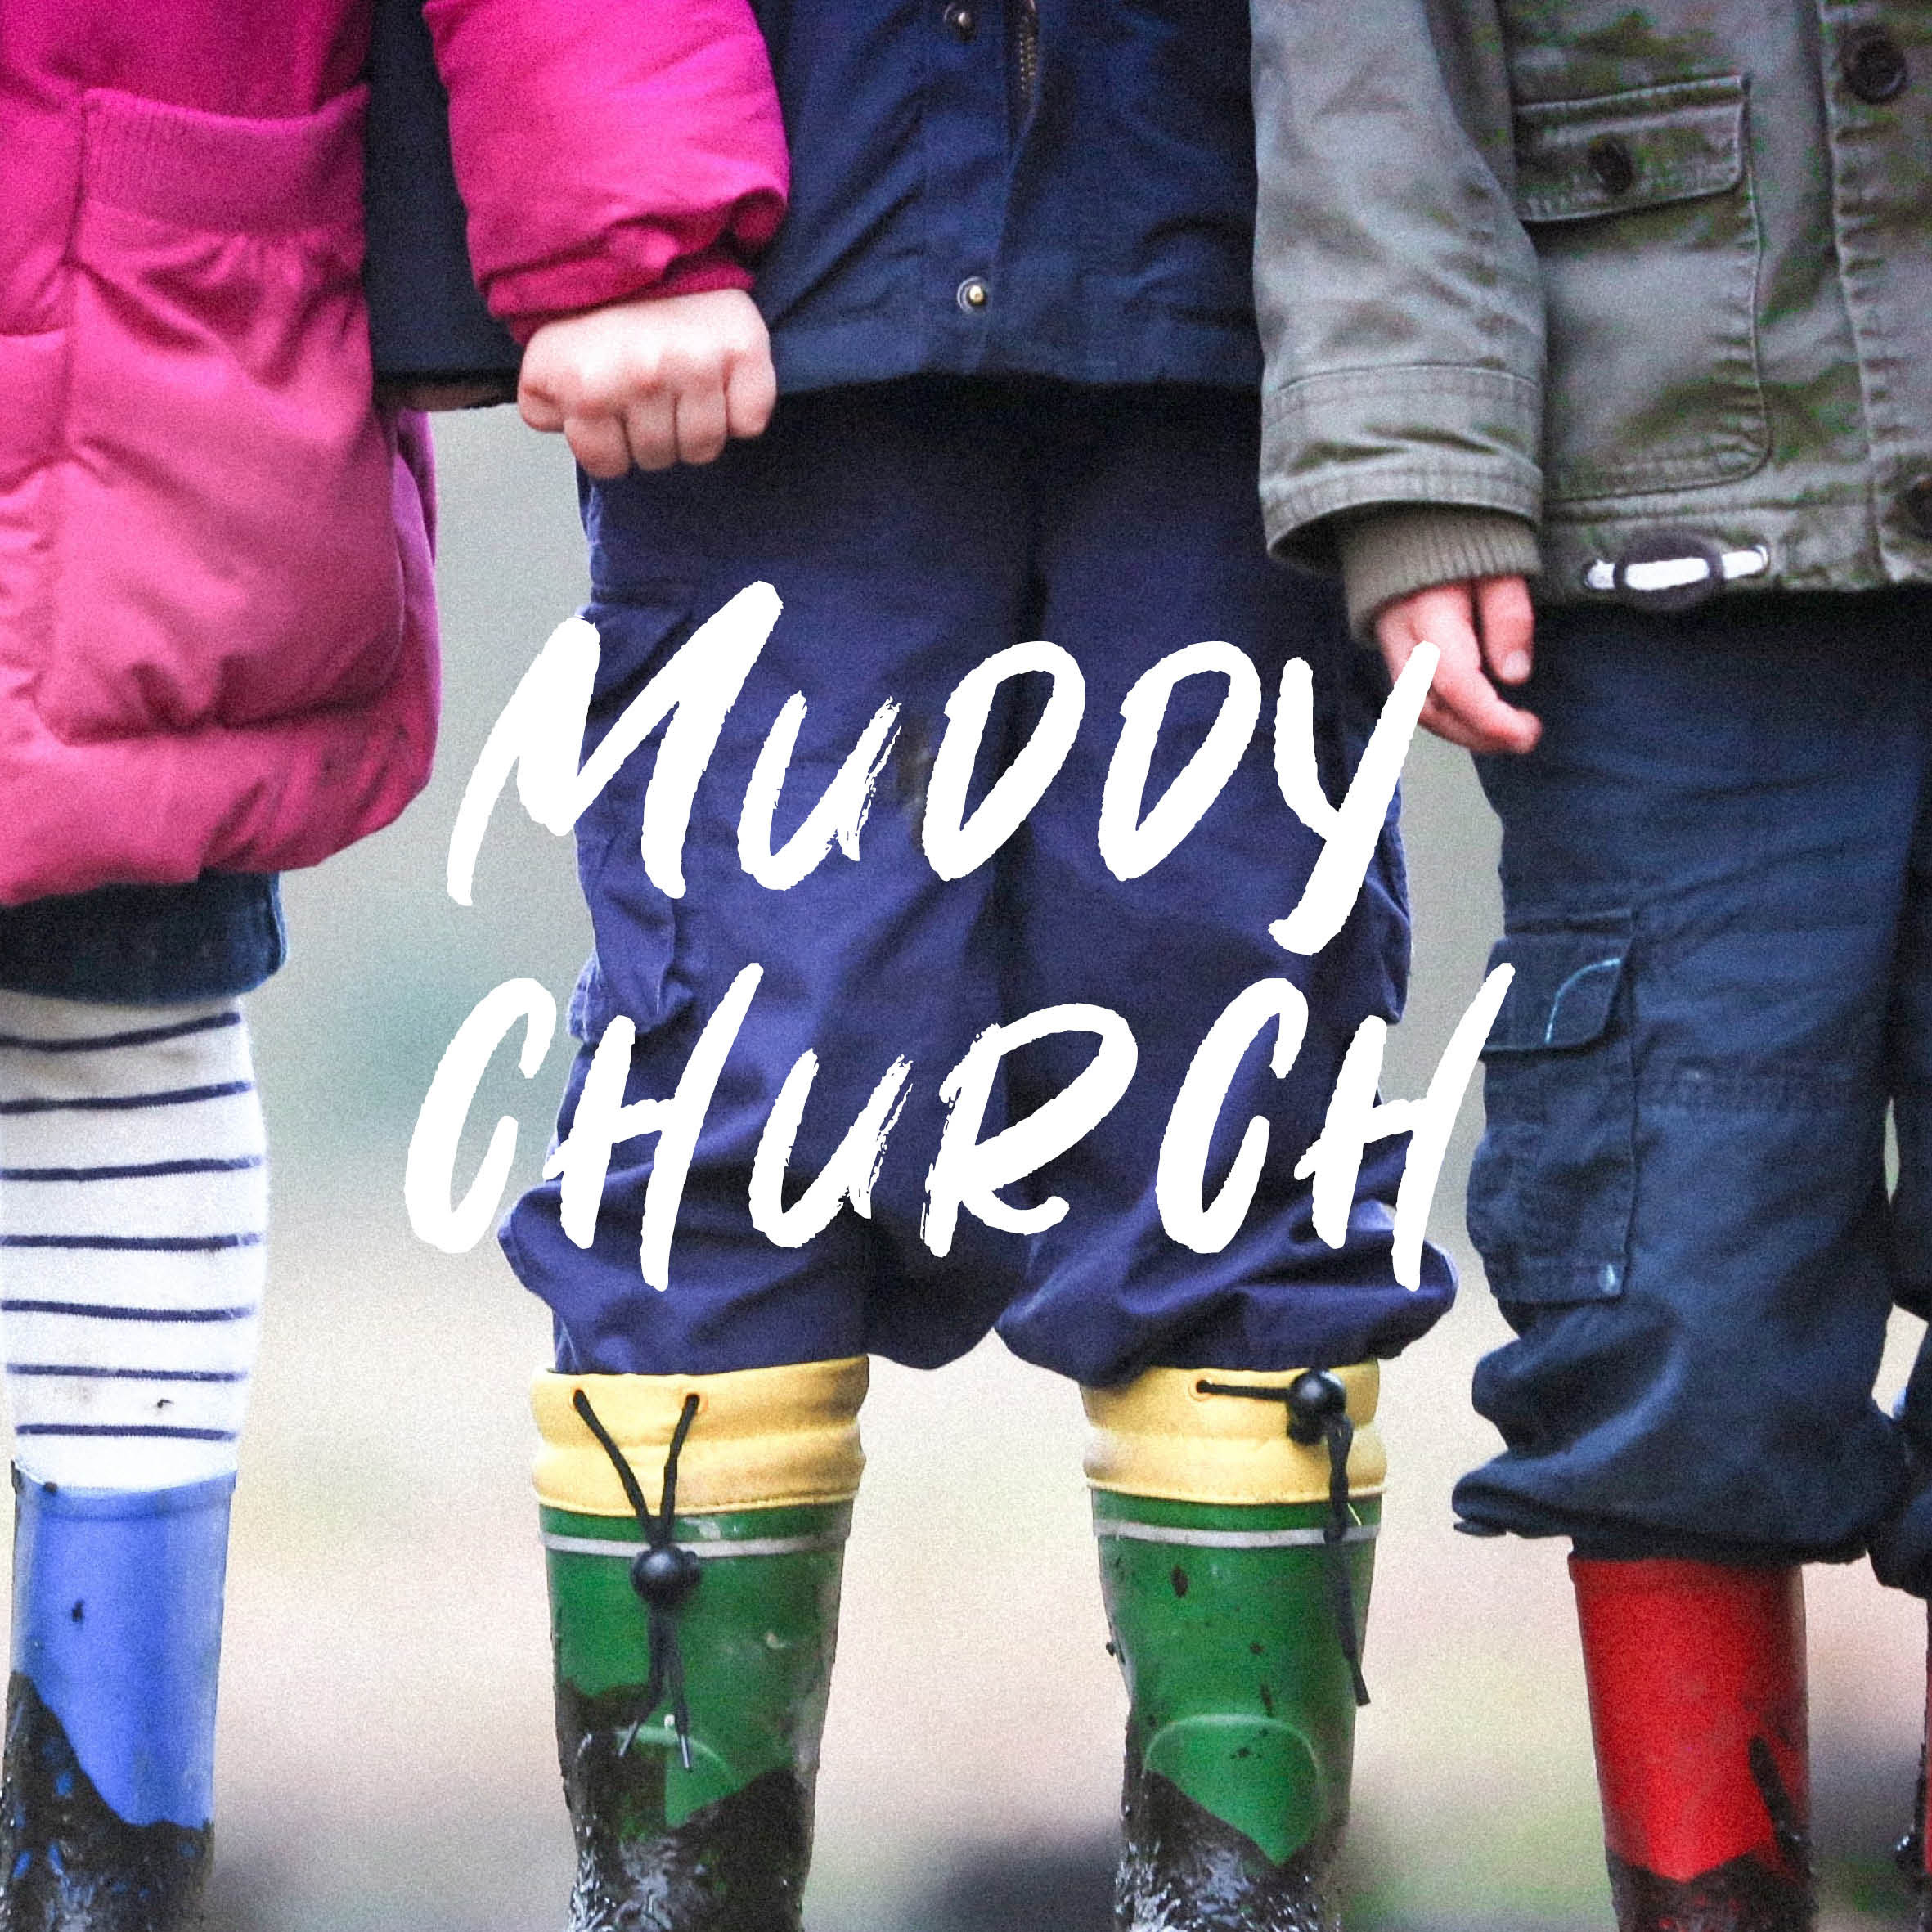
An hour of outdoor fun and crafts focused on learning about God and where, this time, the focus will be on the Holy Spirit. There's blind fold games, explosive prayer dropping and how to make a spark (safely!) as well as glue crosses, inflating balloons, make your own cross bangles and opening water shape prayers. As well, there's our usual special Tots Table, s'mores and fire. Well done to:- Robbie and Daniel G + Esme, Zach H, Lucy & Ethan W, Kaylee B, Joseph G, James K, Archie & Holly S and William B, who all 'Made It' round April’s Muddy Church bases.
For more details about our services, please contact Rev Sue: susanktimmins@aol.com

