Coming Up for Families at
Christ Church Parbold in April
Sunday 5th April – 10:30am
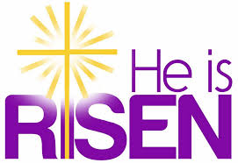
All Age Easter Sunday and Holy Communion Service
A warm welcome to everyone as we celebrate Easter with this special all age service which also features our Youth Pop Up Band. The service will be followed by our Easter Egg Hunt for both school and pre-school children.
Sunday 19th April – 9:30am
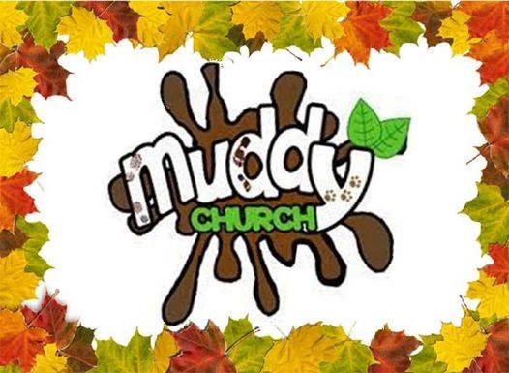
Muddy Church at the Hut
An hour of outdoor fun and crafts focused on learning about God and where, this time, the focus will be on the Resurrection on Easter Sunday. We'll have a bouncing ball experiment, cross and rainbow painting, expanding balloons. MYO nail or twig crosses, fizzy resurrection lemons and prayer jar fireworks. As well, there's our usual special Tots Table, s'mores and fire. Well done to:- Phoebe S, Archie S, Daniel N who all 'Made It' round March’s Muddy Church bases.

Sunday 19th April – 6:00pm
Soul Action Café (Youth)
Our youth group is for Year 7+ and meets in the Scout Hut.
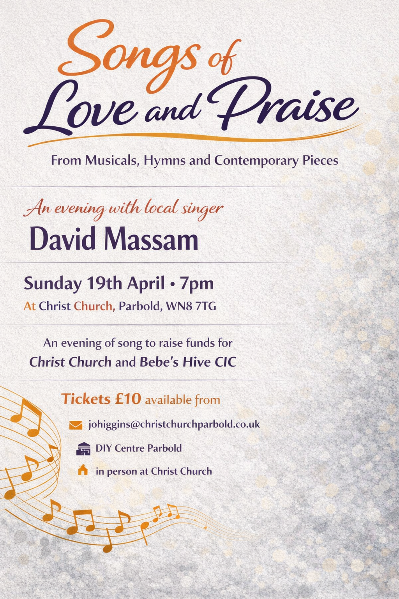
Sunday 19th April – 7:00pm
Songs of Love and Praise
Join local singer David Massam for a concert selection of songs, hymns and contemporary pieces. Tickets £10 from Parbold DIY.
Sunday 26th April – 10:30am
Junior Church & Weekly Children’s Resources

Junior Church meets in the Scout Hut for ages 4–13. At the back of church each week we also have:
• Tots’ Area (0–3yrs)
• Lending Library
• Resource Table with extra children’s activities
For more details about our services, please contact Rev Sue: susanktimmins@aol.com

