Coming Up for Families
Christ Church Parbold – March

Sunday 1st March – 9:30am

Family Service – Theme ‘Rest for our Souls’
Join us in church for our lively and interactive Family Service which also features our Pop Up Youth Band.
――――――――――――――――――――――――――――――――――――――――――――――――――
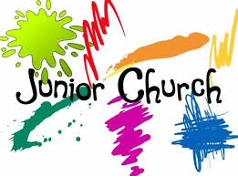
Sunday’s 8th & 22nd March – 10:30am
Junior Church & Weekly Children’s Resources
Junior Church meets in the Scout Hut for ages 4–13. At the back of church each week we also have:
• Tots’ Area (0–3yrs)
• Lending Library
• Resource Table with extra children’s activities

――――――――――――――――――――――――――――――――――――――――――――――――――
Sunday 8th &22nd March – 6:00pm
Soul Action Café (Youth)
Our youth group for Year 7+ which meets in the Scout Hut.
――――――――――――――――――――――――――――――――――――――――――――――――――
Sunday 15th March – 9:30am
Muddy Church at the Hut
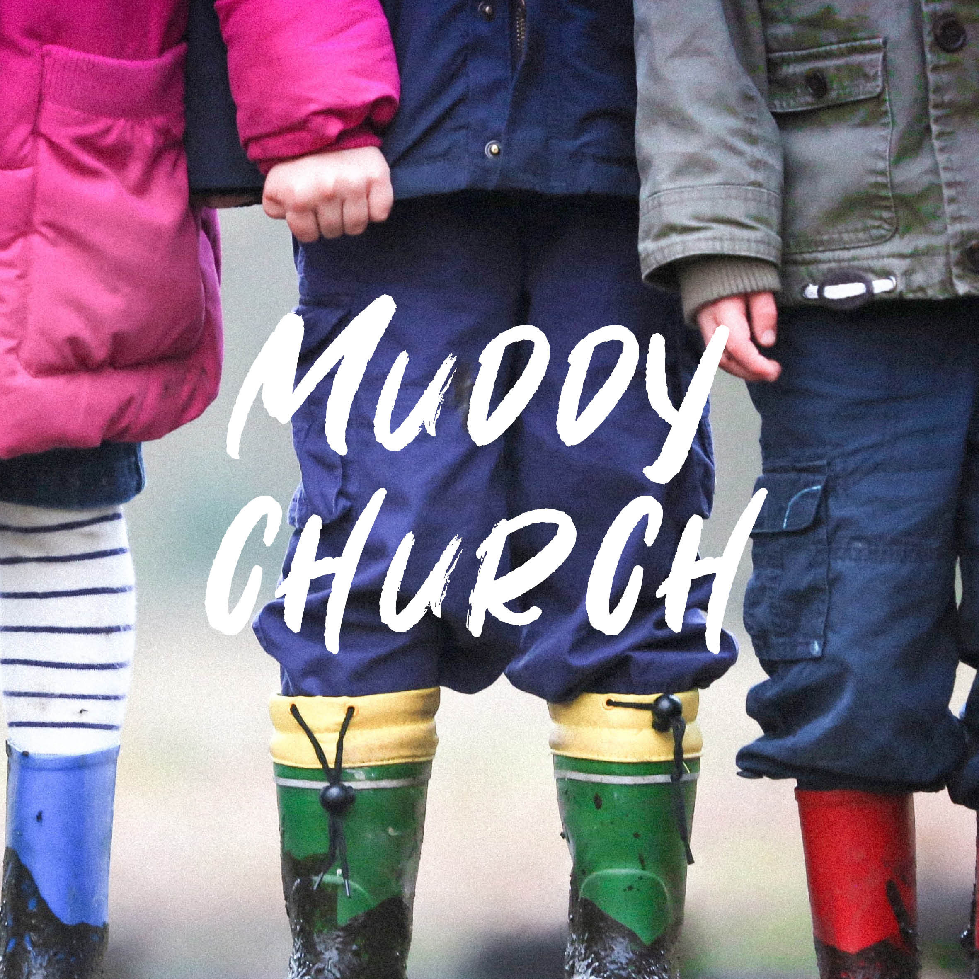
An hour of outdoor fun and crafts focused on learning about God, exploring the theme of Lent and forgiveness. Activities include games, creative prayer stations, egg painting and rolling, making prayer crafts, lava lamps, and a “God’s light breaks the darkness” trick, plus a special Tots Table, s’mores, and a fire.

Well done to Aidan & Phoebe S, Archie S, Teddy L, Henry B and Harry L who all 'Made It' round February’s Muddy Church bases.
For more details about our services, please contact Rev Sue: susanktimmins@aol.com

